|  |
| --- |
| Prabu Digital Profile |
| *WireFrame & Interaction Documentation*  *A role-focused self-product showcasing UX structure and recruiter engagement* |
|  |
| | Prepared by: Prabu Kalidoss | | --- | | Date: 14th June 2025 | | Version: 1.0 | | Location: Madhavaram, Chennai |   *Chennai, Tamil Nadu*  *📞 +91 9884764300 | 📧* [*gideonprabu@gmail.com*](mailto:gideonprabu@gmail.com)  ***LinkedIn:*** [***My Portfolio***](https://www.linkedin.com/in/prabu1301)  ***Services & Portfolio:*** [***linkedin.com/services/page/0559253381839497ab***](http://linkedin.com/services/page/0559253381839497ab) |
|  |

**Objective:** "This document showcases the UX wireframes and interaction logic of Prabu Digital Profile, a recruiter-focused self product."

**Scope:** A one-liner about the role-based personalization strategy.

**Table of Contents**

1.1. New Landing Page 2

1.1.1.1. User Interface 3

1.1.1.2. Interaction Notes 3

1.1.2. New BA/Senior BA/Lead BA Profile 5

1.1.2.1. User Interface 6

1.1.2.2. Interaction Notes 6

1.1.3. Product Owner Profile Page 8

1.1.3.1. User Interface 9

1.1.3.2. Interaction Notes 9

1.1.3.3. Project Manager Profile Page 11

1.1.3.4. User Interface 12

1.1.3.5. Interaction Notes 12

1.1.4. Product Manager Profile Page 14

1.1.4.1. User Interface 15

1.1.4.2. Interaction Notes 15

1.1.5. Agile Coach Profile Page 17

1.1.5.1. User Interface 18

1.1.5.2. Interaction Notes 18

1.1.6. Projects Page 20

1.1.6.1. User Interface 21

1.1.6.2. Interaction Notes 21

1.1.7. Product Demo Page 23

1.1.7.1. User Interface 24

1.1.7.2. Interaction Notes 24

1.1.8. About Me Page 25

1.1.8.1. User Interface 26

1.1.8.2. Interaction Notes 26

1.1.9. Contact Page 27

1.1.1. User Interface 28

1.1.2. Interaction Notes 28

# New **Landing Page**

The Landing Page serves as the entry point to Prabu Digital Profile. It offers clear navigation to recruiter-focused sections,

including tailored profiles and project content.

## User Interface

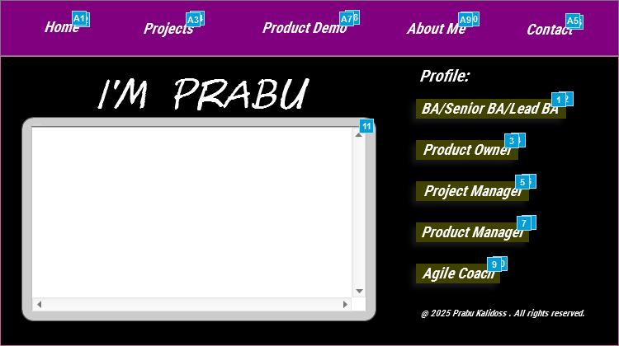

## Interaction Notes

| **Footnote** | **Name** | **Interactions** | **New Note** | **Text** |
| --- | --- | --- | --- | --- |
| 1 | BA/Senior BA/Lead BA-Text-Hyperlink | OnClick:  Case 1:  Show OnClickEffectBA/SeniorBA/LeadBA bring to front  Wait 300 ms  Open New BA/Senior BA/Lead BA Profile in New Window/Tab | OnClick, Display BA/Senior BA/Lead BA profile page | BA/Senior BA/Lead BA |
| 2 | OnClickEffectBA/SeniorBA/LeadBA | OnClick:  Case 1:  Show/Hide Widget  Wait 300 ms  Open New_Landing Page in New Window/Tab |  |  |
| 3 | Product Owner-Text-Hyperlink | OnClick:  Case 1:  Show OnClickEffectProductOwner bring to front  Wait 300 ms  Open New Product Owner Profile in New Window/Tab | OnClick, Display Profile profile page | Product Owner |
| 4 | OnClickEffectProductOwner | OnClick:  Case 1:  Show/Hide Widget  Wait 300 ms  Open Link in New Window/Tab |  |  |
| 5 | Project Manager-Text-Hyperlink | OnClick:  Case 1:  Show OnClickEffectProject Manager bring to front  Wait 300 ms  Open New Project Manager Profile in New Window/Tab | OnClick, Display Project Manager profile page | Project Manager |
| 6 | OnClickEffectProject Manager | OnClick:  Case 1:  Show/Hide Widget  Wait 300 ms  Open Link in New Window/Tab |  |  |
| 7 | Product Manager-Text-Hyperlink | OnClick:  Case 1:  Show OnClickEffectProductManager bring to front  Wait 300 ms  Open New Product Manager Profile in New Window/Tab | OnClick, Display Product Manager profile page | Product Manager |
| 8 | OnClickEffectProductManager | OnClick:  Case 1:  Show/Hide Widget  Wait 300 ms  Open Link in New Window/Tab |  |  |
| 9 | Agile Coach-Text-Hyperlink | OnClick:  Case 1:  Show OnClickEffectAgileCoach bring to front  Wait 300 ms  Open New Agile Coach Profile in New Window/Tab | OnClick, Displays Agile Coach profile page | Agile Coach |
| 10 | OnClickEffectAgileCoach | OnClick:  Case 1:  Show/Hide Widget  Wait 300 ms  Open Link in New Window/Tab |  |  |
| 11 | IntroVideoDynamic Panel | OnClick:  Case 1:  Set text on Unidentified equal to text on Unidentified  Open https://www.youtube.com/embed/PFIcdr8M-iA?wmode=transparent in InlineFrameSelfVideo | OnClick, Plays introduction video within the frame Tooltip/MouseHover-Self Introduction Video |  |
| A1 | Home Text-Hyperlink | OnClick:  Case 1:  Show OnClickEffectHome bring to front  Wait 300 ms  Open New_Landing Page in New Window/Tab | OnClick-Displays the Landing Page | Home |
| A2 | OnClickEffectHome | OnClick:  Case 1:  Show/Hide Widget  Wait 300 ms  Open New_Landing Page in New Window/Tab |  |  |
| A3 | Projects Text-Hyperlink | OnClick:  Case 1:  Show OnClickEffectProjects bring to front  Wait 300 ms  Open New_Projects Page in New Window/Tab | OnClick-Displays the Projects Page in the next tab | Projects |
| A4 | OnClickEffectProjects | OnClick:  Case 1:  Show/Hide Widget  Wait 300 ms  Open New_Landing Page in New Window/Tab |  |  |
| A5 | Contact-Text-Hyperlink | OnClick:  Case 1:  Show OnClickEffectContact bring to front  Wait 300 ms  Open New_Contact Page in New Window/Tab | OnClick-Displays the Contact page in the next tab | Contact |
| A6 | OnClickEffectContact | OnClick:  Case 1:  Show/Hide Widget  Wait 300 ms  Open New_Landing Page in New Window/Tab |  |  |
| A7 | Product Demo-Text-Hyperlink | OnClick:  Case 1:  Show OnClickEffectProductDemo bring to front  Wait 300 ms  Open New_Product DemoPage in New Window/Tab | OnClick-Displays the Product Demo page in the next tab | Product Demo |
| A8 | OnClickEffectProductDemo | OnClick:  Case 1:  Show/Hide Widget  Wait 300 ms  Open New_Landing Page in New Window/Tab |  |  |
| A9 | About Me-Text-Hyperlink | OnClick:  Case 1:  Show OnClickEffectAboutMe bring to front  Wait 300 ms  Open New_About Me Page in New Window/Tab | OnClick-Displays About me page in the new tab | About Me |
| A10 | OnClickEffectAboutMe | OnClick:  Case 1:  Show/Hide Widget  Wait 300 ms  Open New_Landing Page in New Window/Tab |  |  |

# **New BA/Senior BA/Lead BA Profile**

## User Interface

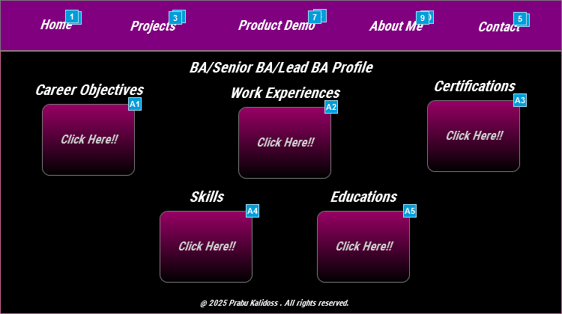

## Interaction Notes

| **Footnote** | **Name** | **Interactions** | **New Note** | **Text** | **ToolTip** |
| --- | --- | --- | --- | --- | --- |
| 1 | Home Text-Hyperlink | OnClick:  Case 1:  Show OnClickEffectHome bring to front  Wait 300 ms  Open New_Landing Page in New Window/Tab | OnClick-Displays the Landing Page | Home |  |
| 2 | OnClickEffectHome | OnClick:  Case 1:  Show/Hide Widget  Wait 300 ms  Open New_Landing Page in New Window/Tab |  |  |  |
| 3 | Projects Text-Hyperlink | OnClick:  Case 1:  Show OnClickEffectProjects bring to front  Wait 300 ms  Open New_Projects Page in New Window/Tab | OnClick-Displays the Projects Page in the next tab | Projects |  |
| 4 | OnClickEffectProjects | OnClick:  Case 1:  Show/Hide Widget  Wait 300 ms  Open New_Landing Page in New Window/Tab |  |  |  |
| 5 | Contact-Text-Hyperlink | OnClick:  Case 1:  Show OnClickEffectContact bring to front  Wait 300 ms  Open New_Contact Page in New Window/Tab | OnClick-Displays the Contact page in the next tab | Contact |  |
| 6 | OnClickEffectContact | OnClick:  Case 1:  Show/Hide Widget  Wait 300 ms  Open New_Landing Page in New Window/Tab |  |  |  |
| 7 | Product Demo-Text-Hyperlink | OnClick:  Case 1:  Show OnClickEffectProductDemo bring to front  Wait 300 ms  Open New_Product DemoPage in New Window/Tab | OnClick-Displays the Product Demo page in the next tab | Product Demo |  |
| 8 | OnClickEffectProductDemo | OnClick:  Case 1:  Show/Hide Widget  Wait 300 ms  Open New_Landing Page in New Window/Tab |  |  |  |
| 9 | About Me-Text-Hyperlink | OnClick:  Case 1:  Show OnClickEffectAboutMe bring to front  Wait 300 ms  Open New_About Me Page in New Window/Tab | OnClick-Displays About me page in the new tab | About Me |  |
| 10 | OnClickEffectAboutMe | OnClick:  Case 1:  Show/Hide Widget  Wait 300 ms  Open New_Landing Page in New Window/Tab |  |  |  |
| A1 | CareerObjectivesButton | OnClick:  Case 1:  Open https://raw.githubusercontent.com/Prabu1301/PrabuDigitalProfile/main/Dummy_Business_Analyst_Prabu_Resume.docx.pdf in Popup Window | OnClick, open Career Objectives PDF | Click Here!! | My Career Objectives |
| A2 | WorkExperienceButton | OnClick:  Case 1:  Open https://raw.githubusercontent.com/Prabu1301/PrabuDigitalProfile/main/Dummy_Business_Analyst_Prabu_Resume.docx.pdf in Popup Window | OnClick, displays Work Experience pdf | Click Here!! | My Work Experiences |
| A3 | Certifications | OnClick:  Case 1:  Open https://raw.githubusercontent.com/Prabu1301/PrabuDigitalProfile/main/Dummy_Business_Analyst_Prabu_Resume.docx.pdf in Popup Window | OnClick, displays Certifications pdf | Click Here!! | My Certifications |
| A4 | SkillsButton | OnClick:  Case 1:  Open https://raw.githubusercontent.com/Prabu1301/PrabuDigitalProfile/main/Dummy_Business_Analyst_Prabu_Resume.docx.pdf in Popup Window | OnClick, displays Skills PDF | Click Here!! | My Skills |
| A5 | EducationsButton | OnClick:  Case 1:  Open https://raw.githubusercontent.com/Prabu1301/PrabuDigitalProfile/main/Dummy_Business_Analyst_Prabu_Resume.docx.pdf in Popup Window | OnClick, displays Educations PDF | Click Here!! | My Educations |

# Product Owner Profile Page

## User Interface

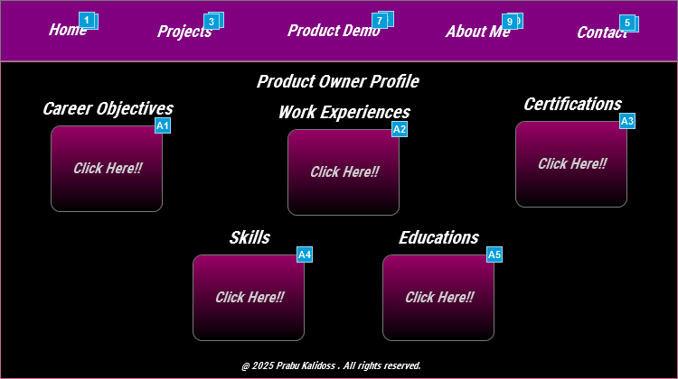

## Interaction Notes

| **Footnote** | **Name** | **Interactions** | **New Note** | **Text** | **ToolTip** |
| --- | --- | --- | --- | --- | --- |
| 1 | Home Text-Hyperlink | OnClick:  Case 1:  Show OnClickEffectHome bring to front  Wait 300 ms  Open New_Landing Page in New Window/Tab | OnClick-Displays the Landing Page | Home |  |
| 2 | OnClickEffectHome | OnClick:  Case 1:  Show/Hide Widget  Wait 300 ms  Open New_Landing Page in New Window/Tab |  |  |  |
| 3 | Projects Text-Hyperlink | OnClick:  Case 1:  Show OnClickEffectProjects bring to front  Wait 300 ms  Open New_Projects Page in New Window/Tab | OnClick-Displays the Projects Page in the next tab | Projects |  |
| 4 | OnClickEffectProjects | OnClick:  Case 1:  Show/Hide Widget  Wait 300 ms  Open New_Landing Page in New Window/Tab |  |  |  |
| 5 | Contact-Text-Hyperlink | OnClick:  Case 1:  Show OnClickEffectContact bring to front  Wait 300 ms  Open New_Contact Page in New Window/Tab | OnClick-Displays the Contact page in the next tab | Contact |  |
| 6 | OnClickEffectContact | OnClick:  Case 1:  Show/Hide Widget  Wait 300 ms  Open New_Landing Page in New Window/Tab |  |  |  |
| 7 | Product Demo-Text-Hyperlink | OnClick:  Case 1:  Show OnClickEffectProductDemo bring to front  Wait 300 ms  Open New_Product DemoPage in New Window/Tab | OnClick-Displays the Product Demo page in the next tab | Product Demo |  |
| 8 | OnClickEffectProductDemo | OnClick:  Case 1:  Show/Hide Widget  Wait 300 ms  Open New_Landing Page in New Window/Tab |  |  |  |
| 9 | About Me-Text-Hyperlink | OnClick:  Case 1:  Show OnClickEffectAboutMe bring to front  Wait 300 ms  Open New_About Me Page in New Window/Tab | OnClick-Displays About me page in the new tab | About Me |  |
| 10 | OnClickEffectAboutMe | OnClick:  Case 1:  Show/Hide Widget  Wait 300 ms  Open New_Landing Page in New Window/Tab |  |  |  |
| A1 | CareerObjectivesButton | OnClick:  Case 1:  Open https://raw.githubusercontent.com/Prabu1301/PrabuDigitalProfile/main/Dummy_Business_Analyst_Prabu_Resume.docx.pdf in Popup Window | OnClick, open Career Objectives PDF | Click Here!! | My Career Objectives |
| A2 | WorkExperienceButton | OnClick:  Case 1:  Open https://raw.githubusercontent.com/Prabu1301/PrabuDigitalProfile/main/Dummy_Business_Analyst_Prabu_Resume.docx.pdf in Popup Window | OnClick, displays Work Experience pdf | Click Here!! | My Work Experiences |
| A3 | Certifications | OnClick:  Case 1:  Open https://raw.githubusercontent.com/Prabu1301/PrabuDigitalProfile/main/Dummy_Business_Analyst_Prabu_Resume.docx.pdf in Popup Window | OnClick, displays Certifications pdf | Click Here!! | My Certifications |
| A4 | SkillsButton | OnClick:  Case 1:  Open https://raw.githubusercontent.com/Prabu1301/PrabuDigitalProfile/main/Dummy_Business_Analyst_Prabu_Resume.docx.pdf in Popup Window | OnClick, displays Skills PDF | Click Here!! | My Skills |
| A5 | EducationsButton | OnClick:  Case 1:  Open https://raw.githubusercontent.com/Prabu1301/PrabuDigitalProfile/main/Dummy_Business_Analyst_Prabu_Resume.docx.pdf in Popup Window | OnClick, displays Educations PDF | Click Here!! | My Educations |

# **Project Manager Profile Page**

## User Interface

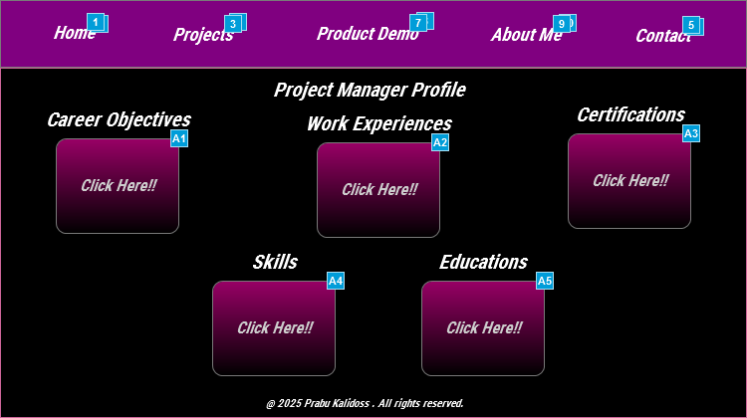

## Interaction Notes

| **Footnote** | **Name** | **Interactions** | **New Note** | **Text** | **ToolTip** |
| --- | --- | --- | --- | --- | --- |
| 1 | Home Text-Hyperlink | OnClick:  Case 1:  Show OnClickEffectHome bring to front  Wait 300 ms  Open New_Landing Page in New Window/Tab | OnClick-Displays the Landing Page | Home |  |
| 2 | OnClickEffectHome | OnClick:  Case 1:  Show/Hide Widget  Wait 300 ms  Open New_Landing Page in New Window/Tab |  |  |  |
| 3 | Projects Text-Hyperlink | OnClick:  Case 1:  Show OnClickEffectProjects bring to front  Wait 300 ms  Open New_Projects Page in New Window/Tab | OnClick-Displays the Projects Page in the next tab | Projects |  |
| 4 | OnClickEffectProjects | OnClick:  Case 1:  Show/Hide Widget  Wait 300 ms  Open New_Landing Page in New Window/Tab |  |  |  |
| 5 | Contact-Text-Hyperlink | OnClick:  Case 1:  Show OnClickEffectContact bring to front  Wait 300 ms  Open New_Contact Page in New Window/Tab | OnClick-Displays the Contact page in the next tab | Contact |  |
| 6 | OnClickEffectContact | OnClick:  Case 1:  Show/Hide Widget  Wait 300 ms  Open New_Landing Page in New Window/Tab |  |  |  |
| 7 | Product Demo-Text-Hyperlink | OnClick:  Case 1:  Show OnClickEffectProductDemo bring to front  Wait 300 ms  Open New_Product DemoPage in New Window/Tab | OnClick-Displays the Product Demo page in the next tab | Product Demo |  |
| 8 | OnClickEffectProductDemo | OnClick:  Case 1:  Show/Hide Widget  Wait 300 ms  Open New_Landing Page in New Window/Tab |  |  |  |
| 9 | About Me-Text-Hyperlink | OnClick:  Case 1:  Show OnClickEffectAboutMe bring to front  Wait 300 ms  Open New_About Me Page in New Window/Tab | OnClick-Displays About me page in the new tab | About Me |  |
| 10 | OnClickEffectAboutMe | OnClick:  Case 1:  Show/Hide Widget  Wait 300 ms  Open New_Landing Page in New Window/Tab |  |  |  |
| A1 | CareerObjectivesButton | OnClick:  Case 1:  Open https://raw.githubusercontent.com/Prabu1301/PrabuDigitalProfile/main/Dummy_Business_Analyst_Prabu_Resume.docx.pdf in Popup Window | OnClick, open Career Objectives PDF | Click Here!! | My Career Objectives |
| A2 | WorkExperienceButton | OnClick:  Case 1:  Open https://raw.githubusercontent.com/Prabu1301/PrabuDigitalProfile/main/Dummy_Business_Analyst_Prabu_Resume.docx.pdf in Popup Window | OnClick, displays Work Experience pdf | Click Here!! | My Work Experiences |
| A3 | Certifications | OnClick:  Case 1:  Open https://raw.githubusercontent.com/Prabu1301/PrabuDigitalProfile/main/Dummy_Business_Analyst_Prabu_Resume.docx.pdf in Popup Window | OnClick, displays Certifications pdf | Click Here!! | My Certifications |
| A4 | SkillsButton | OnClick:  Case 1:  Open https://raw.githubusercontent.com/Prabu1301/PrabuDigitalProfile/main/Dummy_Business_Analyst_Prabu_Resume.docx.pdf in Popup Window | OnClick, displays Skills PDF | Click Here!! | My Skills |
| A5 | EducationsButton | OnClick:  Case 1:  Open https://raw.githubusercontent.com/Prabu1301/PrabuDigitalProfile/main/Dummy_Business_Analyst_Prabu_Resume.docx.pdf in Popup Window | OnClick, displays Educations PDF | Click Here!! | My Educations |

# **Product Manager Profile Page**

## User Interface

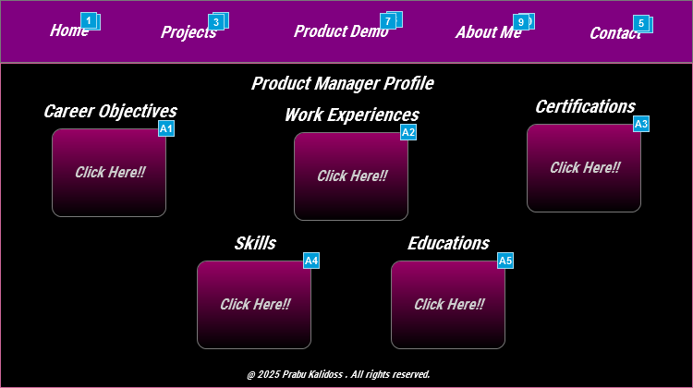

## Interaction Notes

| **Footnote** | **Name** | **Interactions** | **New Note** | **Text** | **ToolTip** |
| --- | --- | --- | --- | --- | --- |
| 1 | Home Text-Hyperlink | OnClick:  Case 1:  Show OnClickEffectHome bring to front  Wait 300 ms  Open New_Landing Page in New Window/Tab | OnClick-Displays the Landing Page | Home |  |
| 2 | OnClickEffectHome | OnClick:  Case 1:  Show/Hide Widget  Wait 300 ms  Open New_Landing Page in New Window/Tab |  |  |  |
| 3 | Projects Text-Hyperlink | OnClick:  Case 1:  Show OnClickEffectProjects bring to front  Wait 300 ms  Open New_Projects Page in New Window/Tab | OnClick-Displays the Projects Page in the next tab | Projects |  |
| 4 | OnClickEffectProjects | OnClick:  Case 1:  Show/Hide Widget  Wait 300 ms  Open New_Landing Page in New Window/Tab |  |  |  |
| 5 | Contact-Text-Hyperlink | OnClick:  Case 1:  Show OnClickEffectContact bring to front  Wait 300 ms  Open New_Contact Page in New Window/Tab | OnClick-Displays the Contact page in the next tab | Contact |  |
| 6 | OnClickEffectContact | OnClick:  Case 1:  Show/Hide Widget  Wait 300 ms  Open New_Landing Page in New Window/Tab |  |  |  |
| 7 | Product Demo-Text-Hyperlink | OnClick:  Case 1:  Show OnClickEffectProductDemo bring to front  Wait 300 ms  Open New_Product DemoPage in New Window/Tab | OnClick-Displays the Product Demo page in the next tab | Product Demo |  |
| 8 | OnClickEffectProductDemo | OnClick:  Case 1:  Show/Hide Widget  Wait 300 ms  Open New_Landing Page in New Window/Tab |  |  |  |
| 9 | About Me-Text-Hyperlink | OnClick:  Case 1:  Show OnClickEffectAboutMe bring to front  Wait 300 ms  Open New_About Me Page in New Window/Tab | OnClick-Displays About me page in the new tab | About Me |  |
| 10 | OnClickEffectAboutMe | OnClick:  Case 1:  Show/Hide Widget  Wait 300 ms  Open New_Landing Page in New Window/Tab |  |  |  |
| A1 | CareerObjectivesButton | OnClick:  Case 1:  Open https://raw.githubusercontent.com/Prabu1301/PrabuDigitalProfile/main/Dummy_Business_Analyst_Prabu_Resume.docx.pdf in Popup Window | OnClick, open Career Objectives PDF | Click Here!! | My Career Objectives |
| A2 | WorkExperienceButton | OnClick:  Case 1:  Open https://raw.githubusercontent.com/Prabu1301/PrabuDigitalProfile/main/Dummy_Business_Analyst_Prabu_Resume.docx.pdf in Popup Window | OnClick, displays Work Experience pdf | Click Here!! | My Work Experiences |
| A3 | Certifications | OnClick:  Case 1:  Open https://raw.githubusercontent.com/Prabu1301/PrabuDigitalProfile/main/Dummy_Business_Analyst_Prabu_Resume.docx.pdf in Popup Window | OnClick, displays Certifications pdf | Click Here!! | My Certifications |
| A4 | SkillsButton | OnClick:  Case 1:  Open https://raw.githubusercontent.com/Prabu1301/PrabuDigitalProfile/main/Dummy_Business_Analyst_Prabu_Resume.docx.pdf in Popup Window | OnClick, displays Skills PDF | Click Here!! | My Skills |
| A5 | EducationsButton | OnClick:  Case 1:  Open https://raw.githubusercontent.com/Prabu1301/PrabuDigitalProfile/main/Dummy_Business_Analyst_Prabu_Resume.docx.pdf in Popup Window | OnClick, displays Educations PDF | Click Here!! | My Educations |

# **Agile Coach Profile Page**

## User Interface

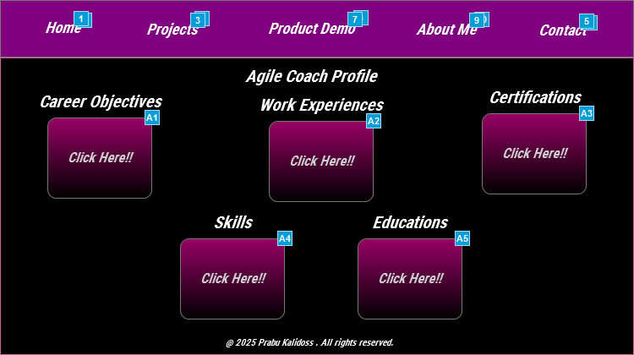

## Interaction Notes

| **Footnote** | **Name** | **Interactions** | **New Note** | **Text** | **ToolTip** |
| --- | --- | --- | --- | --- | --- |
| 1 | Home Text-Hyperlink | OnClick:  Case 1:  Show OnClickEffectHome bring to front  Wait 300 ms  Open New_Landing Page in New Window/Tab | OnClick-Displays the Landing Page | Home |  |
| 2 | OnClickEffectHome | OnClick:  Case 1:  Show/Hide Widget  Wait 300 ms  Open New_Landing Page in New Window/Tab |  |  |  |
| 3 | Projects Text-Hyperlink | OnClick:  Case 1:  Show OnClickEffectProjects bring to front  Wait 300 ms  Open New_Projects Page in New Window/Tab | OnClick-Displays the Projects Page in the next tab | Projects |  |
| 4 | OnClickEffectProjects | OnClick:  Case 1:  Show/Hide Widget  Wait 300 ms  Open New_Landing Page in New Window/Tab |  |  |  |
| 5 | Contact-Text-Hyperlink | OnClick:  Case 1:  Show OnClickEffectContact bring to front  Wait 300 ms  Open New_Contact Page in New Window/Tab | OnClick-Displays the Contact page in the next tab | Contact |  |
| 6 | OnClickEffectContact | OnClick:  Case 1:  Show/Hide Widget  Wait 300 ms  Open New_Landing Page in New Window/Tab |  |  |  |
| 7 | Product Demo-Text-Hyperlink | OnClick:  Case 1:  Show OnClickEffectProductDemo bring to front  Wait 300 ms  Open New_Product DemoPage in New Window/Tab | OnClick-Displays the Product Demo page in the next tab | Product Demo |  |
| 8 | OnClickEffectProductDemo | OnClick:  Case 1:  Show/Hide Widget  Wait 300 ms  Open New_Landing Page in New Window/Tab |  |  |  |
| 9 | About Me-Text-Hyperlink | OnClick:  Case 1:  Show OnClickEffectAboutMe bring to front  Wait 300 ms  Open New_About Me Page in New Window/Tab | OnClick-Displays About me page in the new tab | About Me |  |
| 10 | OnClickEffectAboutMe | OnClick:  Case 1:  Show/Hide Widget  Wait 300 ms  Open New_Landing Page in New Window/Tab |  |  |  |
| A1 | CareerObjectivesButton | OnClick:  Case 1:  Open https://raw.githubusercontent.com/Prabu1301/PrabuDigitalProfile/main/Dummy_Business_Analyst_Prabu_Resume.docx.pdf in Popup Window | OnClick, open Career Objectives PDF | Click Here!! | My Career Objectives |
| A2 | WorkExperienceButton | OnClick:  Case 1:  Open https://raw.githubusercontent.com/Prabu1301/PrabuDigitalProfile/main/Dummy_Business_Analyst_Prabu_Resume.docx.pdf in Popup Window | OnClick, displays Work Experience pdf | Click Here!! | My Work Experiences |
| A3 | Certifications | OnClick:  Case 1:  Open https://raw.githubusercontent.com/Prabu1301/PrabuDigitalProfile/main/Dummy_Business_Analyst_Prabu_Resume.docx.pdf in Popup Window | OnClick, displays Certifications pdf | Click Here!! | My Certifications |
| A4 | SkillsButton | OnClick:  Case 1:  Open https://raw.githubusercontent.com/Prabu1301/PrabuDigitalProfile/main/Dummy_Business_Analyst_Prabu_Resume.docx.pdf in Popup Window | OnClick, displays Skills PDF | Click Here!! | My Skills |
| A5 | EducationsButton | OnClick:  Case 1:  Open https://raw.githubusercontent.com/Prabu1301/PrabuDigitalProfile/main/Dummy_Business_Analyst_Prabu_Resume.docx.pdf in Popup Window | OnClick, displays Educations PDF | Click Here!! | My Educations |

# **Projects Page**

## User Interface

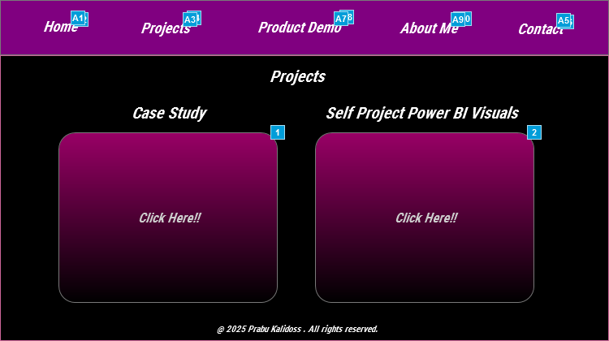

## Interaction Notes

| **Footnote** | **Name** | **Interactions** | **New Note** | **Text** | **ToolTip** |
| --- | --- | --- | --- | --- | --- |
| 1 | CaseStudy Button | OnClick:  Case 1:  Open https://drive.google.com/file/d/1Q8tbPuT4p7tdRdvDfdBNO-__1d5FKYT3/preview in Popup Window | OnClick, opens the case Study pdf in the same window | Click Here!! | Agile Leadership & Product Strategy – Case Study |
| 2 | SelfStudyButton | OnClick:  Case 1:  Open https://drive.google.com/file/d/11TOVLGQ8A20xxZV0Xp7Welee2oY6oqqx/preview in Popup Window | OnClick, opens the Power BI Visuals in the same window | Click Here!! | Stakeholder Insight Project's Power BI Visuals |
| A1 | Home Text-Hyperlink | OnClick:  Case 1:  Show OnClickEffectHome bring to front  Wait 300 ms  Open New_Landing Page in New Window/Tab | OnClick-Displays the Landing Page | Home |  |
| A2 | OnClickEffectHome | OnClick:  Case 1:  Show/Hide Widget  Wait 300 ms  Open New_Landing Page in New Window/Tab |  |  |  |
| A3 | Projects Text-Hyperlink | OnClick:  Case 1:  Show OnClickEffectProjects bring to front  Wait 300 ms  Open New_Projects Page in New Window/Tab | OnClick-Displays the Projects Page in the next tab | Projects |  |
| A4 | OnClickEffectProjects | OnClick:  Case 1:  Show/Hide Widget  Wait 300 ms  Open New_Landing Page in New Window/Tab |  |  |  |
| A5 | Contact-Text-Hyperlink | OnClick:  Case 1:  Show OnClickEffectContact bring to front  Wait 300 ms  Open New_Contact Page in New Window/Tab | OnClick-Displays the Contact page in the next tab | Contact |  |
| A6 | OnClickEffectContact | OnClick:  Case 1:  Show/Hide Widget  Wait 300 ms  Open New_Landing Page in New Window/Tab |  |  |  |
| A7 | Product Demo-Text-Hyperlink | OnClick:  Case 1:  Show OnClickEffectProductDemo bring to front  Wait 300 ms  Open New_Product DemoPage in New Window/Tab | OnClick-Displays the Product Demo page in the next tab | Product Demo |  |
| A8 | OnClickEffectProductDemo | OnClick:  Case 1:  Show/Hide Widget  Wait 300 ms  Open New_Landing Page in New Window/Tab |  |  |  |
| A9 | About Me-Text-Hyperlink | OnClick:  Case 1:  Show OnClickEffectAboutMe bring to front  Wait 300 ms  Open New_About Me Page in New Window/Tab | OnClick-Displays About me page in the new tab | About Me |  |
| A10 | OnClickEffectAboutMe | OnClick:  Case 1:  Show/Hide Widget  Wait 300 ms  Open New_Landing Page in New Window/Tab |  |  |  |

# **Product Demo Page**

## User Interface

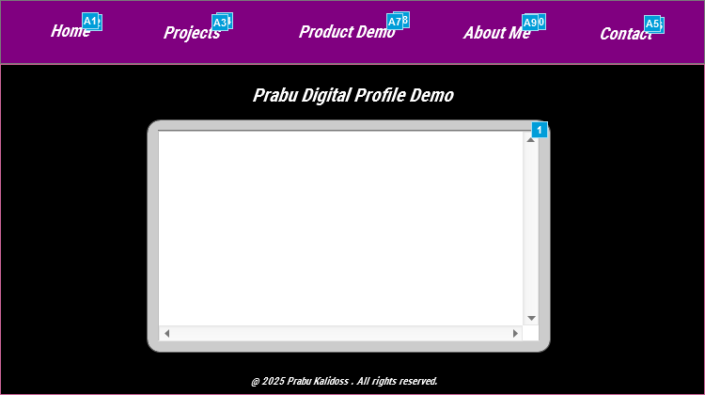

## Interaction Notes

| **Footnote** | **Name** | **Interactions** | **New Note** | **Text** |
| --- | --- | --- | --- | --- |
| 1 | IntroVideoDynamic Panel | OnClick:  Case 1:  Set text on Unidentified equal to text on Unidentified  Open https://www.youtube.com/embed/PFIcdr8M-iA?wmode=transparent in InlineFrameSelfVideo | OnClick, plays product demo video within the frame |  |
| A1 | Home Text-Hyperlink | OnClick:  Case 1:  Show OnClickEffectHome bring to front  Wait 300 ms  Open New_Landing Page in New Window/Tab | OnClick-Displays the Landing Page | Home |
| A2 | OnClickEffectHome | OnClick:  Case 1:  Show/Hide Widget  Wait 300 ms  Open New_Landing Page in New Window/Tab |  |  |
| A3 | Projects Text-Hyperlink | OnClick:  Case 1:  Show OnClickEffectProjects bring to front  Wait 300 ms  Open New_Projects Page in New Window/Tab | OnClick-Displays the Projects Page in the next tab | Projects |
| A4 | OnClickEffectProjects | OnClick:  Case 1:  Show/Hide Widget  Wait 300 ms  Open New_Landing Page in New Window/Tab |  |  |
| A5 | Contact-Text-Hyperlink | OnClick:  Case 1:  Show OnClickEffectContact bring to front  Wait 300 ms  Open New_Contact Page in New Window/Tab | OnClick-Displays the Contact page in the next tab | Contact |
| A6 | OnClickEffectContact | OnClick:  Case 1:  Show/Hide Widget  Wait 300 ms  Open New_Landing Page in New Window/Tab |  |  |
| A7 | Product Demo-Text-Hyperlink | OnClick:  Case 1:  Show OnClickEffectProductDemo bring to front  Wait 300 ms  Open New_Product DemoPage in New Window/Tab | OnClick-Displays the Product Demo page in the next tab | Product Demo |
| A8 | OnClickEffectProductDemo | OnClick:  Case 1:  Show/Hide Widget  Wait 300 ms  Open New_Landing Page in New Window/Tab |  |  |
| A9 | About Me-Text-Hyperlink | OnClick:  Case 1:  Show OnClickEffectAboutMe bring to front  Wait 300 ms  Open New_About Me Page in New Window/Tab | OnClick-Displays About me page in the new tab | About Me |
| A10 | OnClickEffectAboutMe | OnClick:  Case 1:  Show/Hide Widget  Wait 300 ms  Open New_Landing Page in New Window/Tab |  |  |

# **About Me Page**

## User Interface

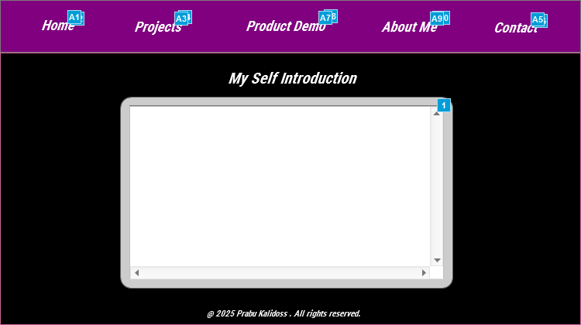

## Interaction Notes

| **Footnote** | **Name** | **Interactions** | **New Note** | **Text** |
| --- | --- | --- | --- | --- |
| 1 | IntroVideoDynamic Panel | OnClick:  Case 1:  Set text on Unidentified equal to text on Unidentified  Open https://www.youtube.com/embed/PFIcdr8M-iA?wmode=transparent in InlineFrameSelfVideo | OnClick, Plays introduction video within the frame Tooltip/MouseHover-Self Introduction Video |  |
| A1 | Home Text-Hyperlink | OnClick:  Case 1:  Show OnClickEffectHome bring to front  Wait 300 ms  Open New_Landing Page in New Window/Tab | OnClick-Displays the Landing Page | Home |
| A2 | OnClickEffectHome | OnClick:  Case 1:  Show/Hide Widget  Wait 300 ms  Open New_Landing Page in New Window/Tab |  |  |
| A3 | Projects Text-Hyperlink | OnClick:  Case 1:  Show OnClickEffectProjects bring to front  Wait 300 ms  Open New_Projects Page in New Window/Tab | OnClick-Displays the Projects Page in the next tab | Projects |
| A4 | OnClickEffectProjects | OnClick:  Case 1:  Show/Hide Widget  Wait 300 ms  Open New_Landing Page in New Window/Tab |  |  |
| A5 | Contact-Text-Hyperlink | OnClick:  Case 1:  Show OnClickEffectContact bring to front  Wait 300 ms  Open New_Contact Page in New Window/Tab | OnClick-Displays the Contact page in the next tab | Contact |
| A6 | OnClickEffectContact | OnClick:  Case 1:  Show/Hide Widget  Wait 300 ms  Open New_Landing Page in New Window/Tab |  |  |
| A7 | Product Demo-Text-Hyperlink | OnClick:  Case 1:  Show OnClickEffectProductDemo bring to front  Wait 300 ms  Open New_Product DemoPage in New Window/Tab | OnClick-Displays the Product Demo page in the next tab | Product Demo |
| A8 | OnClickEffectProductDemo | OnClick:  Case 1:  Show/Hide Widget  Wait 300 ms  Open New_Landing Page in New Window/Tab |  |  |
| A9 | About Me-Text-Hyperlink | OnClick:  Case 1:  Show OnClickEffectAboutMe bring to front  Wait 300 ms  Open New_About Me Page in New Window/Tab | OnClick-Displays About me page in the new tab | About Me |
| A10 | OnClickEffectAboutMe | OnClick:  Case 1:  Show/Hide Widget  Wait 300 ms  Open New_Landing Page in New Window/Tab |  |  |

# **Contact Page**

## User Interface

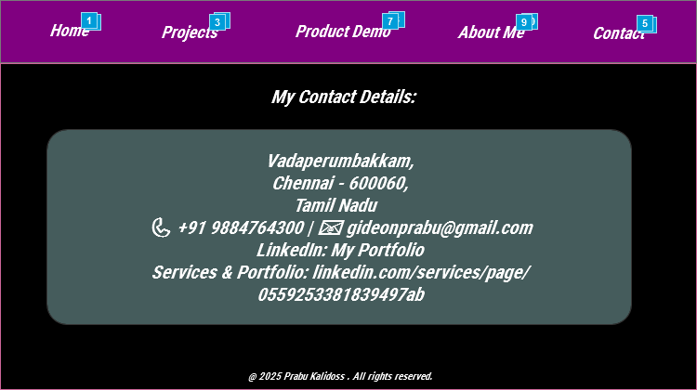

## Interaction Notes

| **Footnote** | **Name** | **Interactions** | **New Note** | **Text** |
| --- | --- | --- | --- | --- |
| 1 | Home Text-Hyperlink | OnClick:  Case 1:  Show OnClickEffectHome bring to front  Wait 300 ms  Open New_Landing Page in New Window/Tab | OnClick-Displays the Landing Page | Home |
| 2 | OnClickEffectHome | OnClick:  Case 1:  Show/Hide Widget  Wait 300 ms  Open New_Landing Page in New Window/Tab |  |  |
| 3 | Projects Text-Hyperlink | OnClick:  Case 1:  Show OnClickEffectProjects bring to front  Wait 300 ms  Open New_Projects Page in New Window/Tab | OnClick-Displays the Projects Page in the next tab | Projects |
| 4 | OnClickEffectProjects | OnClick:  Case 1:  Show/Hide Widget  Wait 300 ms  Open New_Landing Page in New Window/Tab |  |  |
| 5 | Contact-Text-Hyperlink | OnClick:  Case 1:  Show OnClickEffectContact bring to front  Wait 300 ms  Open New_Contact Page in New Window/Tab | OnClick-Displays the Contact page in the next tab | Contact |
| 6 | OnClickEffectContact | OnClick:  Case 1:  Show/Hide Widget  Wait 300 ms  Open New_Landing Page in New Window/Tab |  |  |
| 7 | Product Demo-Text-Hyperlink | OnClick:  Case 1:  Show OnClickEffectProductDemo bring to front  Wait 300 ms  Open New_Product DemoPage in New Window/Tab | OnClick-Displays the Product Demo page in the next tab | Product Demo |
| 8 | OnClickEffectProductDemo | OnClick:  Case 1:  Show/Hide Widget  Wait 300 ms  Open New_Landing Page in New Window/Tab |  |  |
| 9 | About Me-Text-Hyperlink | OnClick:  Case 1:  Show OnClickEffectAboutMe bring to front  Wait 300 ms  Open New_About Me Page in New Window/Tab | OnClick-Displays About me page in the new tab | About Me |
| 10 | OnClickEffectAboutMe | OnClick:  Case 1:  Show/Hide Widget  Wait 300 ms  Open New_Landing Page in New Window/Tab |  |  |

Best Regards,

Prabu Kalidoss

Business Analyst | Product Owner | Product Manager | Agile Coach |